**Mata Kuliah : Pemrograman Perangkat Bergerak -TI – S1**

**Nama : Bayu Prasetya Adji Sugiyarto**

**NIM : A11.2019.11688**

**Pertemuan : 1**

**Hasil Program :**

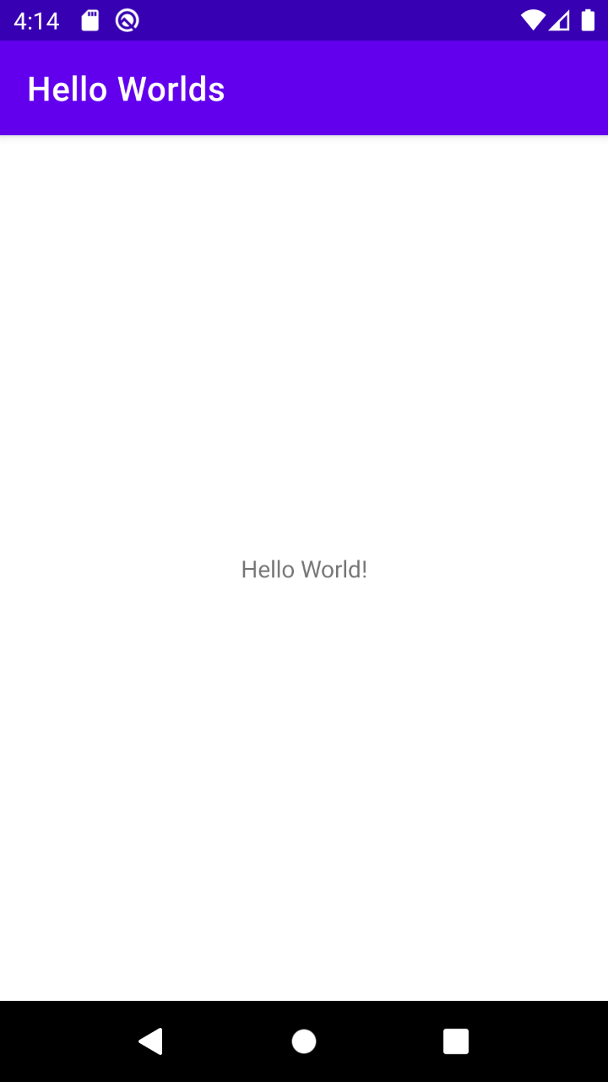

**Layout 🡺** activity_main.xml

*<?*xml version="1.0" encoding="utf-8"*?>*<androidx.constraintlayout.widget.ConstraintLayout xmlns:android="http://schemas.android.com/apk/res/android"  
 xmlns:app="http://schemas.android.com/apk/res-auto"  
 xmlns:tools="http://schemas.android.com/tools"  
 android:layout_width="match_parent"  
 android:layout_height="match_parent"  
 tools:context=".MainActivity">  
  
 <TextView  
 android:layout_width="wrap_content"  
 android:layout_height="wrap_content"  
 android:text="Hello World!"  
 app:layout_constraintBottom_toBottomOf="parent"  
 app:layout_constraintLeft_toLeftOf="parent"  
 app:layout_constraintRight_toRightOf="parent"  
 app:layout_constraintTop_toTopOf="parent" />  
  
</androidx.constraintlayout.widget.ConstraintLayout>

**Java 🡺** MainActivity

package com.example.helloworlds;  
  
import androidx.appcompat.app.AppCompatActivity;  
  
import android.os.Bundle;  
  
public class MainActivity extends AppCompatActivity {  
  
 @Override  
 protected void onCreate(Bundle savedInstanceState) {  
 super.onCreate(savedInstanceState);  
 setContentView(R.layout.*activity_main*);  
 }  
}

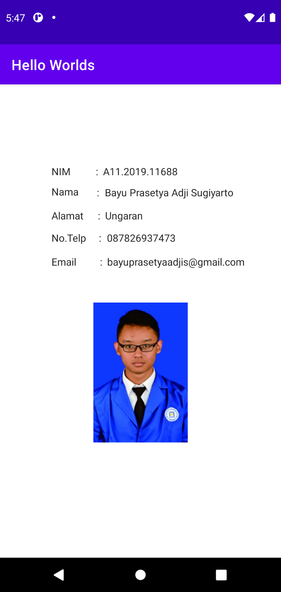**Biodata**

**Code :**

**Layout 🡺** activity_main.xml

*<?*xml version="1.0" encoding="utf-8"*?>*<androidx.constraintlayout.widget.ConstraintLayout xmlns:android="http://schemas.android.com/apk/res/android"  
 xmlns:app="http://schemas.android.com/apk/res-auto"  
 xmlns:tools="http://schemas.android.com/tools"  
 android:layout_width="match_parent"  
 android:layout_height="match_parent"  
 tools:context=".MainActivity">  
  
 <TextView  
 android:id="@+id/textView10"  
 android:layout_width="wrap_content"  
 android:layout_height="wrap_content"  
 android:layout_marginStart="7dp"  
 android:layout_marginBottom="9dp"  
 android:text="A11.2019.11688"  
 android:textAppearance="@style/TextAppearance.AppCompat.Body1"  
 android:visibility="visible"  
 app:layout_constraintBottom_toTopOf="@+id/textView"  
 app:layout_constraintStart_toEndOf="@+id/textView5" />  
  
 <TextView  
 android:id="@+id/textView2"  
 android:layout_width="wrap_content"  
 android:layout_height="wrap_content"  
 android:layout_marginBottom="12dp"  
 android:text="@string/alamat"  
 android:textAppearance="@style/TextAppearance.AppCompat.Body1"  
 android:visibility="visible"  
 app:layout_constraintBottom_toTopOf="@+id/textView3"  
 app:layout_constraintStart_toStartOf="@+id/textView" />  
  
 <TextView  
 android:id="@+id/textView8"  
 android:layout_width="wrap_content"  
 android:layout_height="wrap_content"  
 android:text="@string/titik"  
 android:textAppearance="@style/TextAppearance.AppCompat.Body1"  
 android:visibility="visible"  
 app:layout_constraintBaseline_toBaselineOf="@+id/textView13"  
 app:layout_constraintEnd_toStartOf="@+id/textView9"  
 app:layout_constraintStart_toStartOf="@+id/textView9" />  
  
 <TextView  
 android:id="@+id/textView6"  
 android:layout_width="wrap_content"  
 android:layout_height="wrap_content"  
 android:layout_marginTop="10dp"  
 android:text=":"  
 android:textAppearance="@style/TextAppearance.AppCompat.Body1"  
 android:visibility="visible"  
 app:layout_constraintEnd_toStartOf="@+id/textView7"  
 app:layout_constraintStart_toStartOf="@+id/textView7"  
 app:layout_constraintTop_toBottomOf="@+id/textView5" />  
  
 <TextView  
 android:id="@+id/textView14"  
 android:layout_width="wrap_content"  
 android:layout_height="wrap_content"  
 android:text="bayuprasetyaadjis@gmail.com"  
 android:textAppearance="@style/TextAppearance.AppCompat.Body1"  
 android:visibility="visible"  
 app:layout_constraintBaseline_toBaselineOf="@+id/textView9"  
 app:layout_constraintEnd_toEndOf="@+id/textView13"  
 app:layout_constraintStart_toEndOf="@+id/textView13" />  
  
 <TextView  
 android:id="@+id/textView4"  
 android:layout_width="wrap_content"  
 android:layout_height="wrap_content"  
 android:layout_marginTop="14dp"  
 android:text="@string/email"  
 android:textAppearance="@style/TextAppearance.AppCompat.Body1"  
 android:visibility="visible"  
 app:layout_constraintStart_toStartOf="@+id/textView3"  
 app:layout_constraintTop_toBottomOf="@+id/textView3" />  
  
 <TextView  
 android:id="@+id/textView5"  
 android:layout_width="wrap_content"  
 android:layout_height="wrap_content"  
 android:text=":"  
 android:textAppearance="@style/TextAppearance.AppCompat.Body1"  
 android:visibility="visible"  
 app:layout_constraintBaseline_toBaselineOf="@+id/textView10"  
 app:layout_constraintEnd_toStartOf="@+id/textView6"  
 app:layout_constraintStart_toStartOf="@+id/textView6" />  
  
 <ImageView  
 android:id="@+id/imageView"  
 android:layout_width="132dp"  
 android:layout_height="201dp"  
 android:layout_marginTop="45dp"  
 app:layout_constraintEnd_toEndOf="parent"  
 app:layout_constraintStart_toStartOf="parent"  
 app:layout_constraintTop_toBottomOf="@+id/textView14"  
 app:srcCompat="@drawable/a11_2019_11688" />  
  
 <TextView  
 android:id="@+id/textView7"  
 android:layout_width="wrap_content"  
 android:layout_height="wrap_content"  
 android:text=":"  
 android:textAppearance="@style/TextAppearance.AppCompat.Body1"  
 android:visibility="visible"  
 app:layout_constraintBaseline_toBaselineOf="@+id/textView12"  
 app:layout_constraintEnd_toStartOf="@+id/textView8"  
 app:layout_constraintStart_toStartOf="@+id/textView8" />  
  
 <TextView  
 android:id="@+id/textView"  
 android:layout_width="wrap_content"  
 android:layout_height="wrap_content"  
 android:layout_marginTop="9dp"  
 android:text="@string/nama"  
 android:textAppearance="@style/TextAppearance.AppCompat.Body1"  
 android:visibility="visible"  
 app:layout_constraintStart_toStartOf="@+id/textView15"  
 app:layout_constraintTop_toBottomOf="@+id/textView15" />  
  
 <TextView  
 android:id="@+id/textView3"  
 android:layout_width="wrap_content"  
 android:layout_height="wrap_content"  
 android:text="@string/no_telp"  
 android:textAppearance="@style/TextAppearance.AppCompat.Body1"  
 android:visibility="visible"  
 app:layout_constraintBaseline_toBaselineOf="@+id/textView8"  
 app:layout_constraintStart_toStartOf="@+id/textView2" />  
  
 <TextView  
 android:id="@+id/textView15"  
 android:layout_width="wrap_content"  
 android:layout_height="wrap_content"  
 android:layout_marginStart="72dp"  
 android:layout_marginTop="112dp"  
 android:text="@string/nim"  
 android:textAppearance="@style/TextAppearance.AppCompat.Body1"  
 android:visibility="visible"  
 app:layout_constraintStart_toStartOf="parent"  
 app:layout_constraintTop_toTopOf="parent" />  
  
 <TextView  
 android:id="@+id/textView11"  
 android:layout_width="wrap_content"  
 android:layout_height="wrap_content"  
 android:layout_marginStart="8dp"  
 android:text="Bayu Prasetya Adji Sugiyarto"  
 android:textAppearance="@style/TextAppearance.AppCompat.Body1"  
 android:visibility="visible"  
 app:layout_constraintBaseline_toBaselineOf="@+id/textView6"  
 app:layout_constraintStart_toEndOf="@+id/textView6" />  
  
 <TextView  
 android:id="@+id/textView9"  
 android:layout_width="wrap_content"  
 android:layout_height="wrap_content"  
 android:layout_marginStart="19dp"  
 android:layout_marginTop="14dp"  
 android:text=":"  
 android:textAppearance="@style/TextAppearance.AppCompat.Body1"  
 android:visibility="visible"  
 app:layout_constraintStart_toEndOf="@+id/textView3"  
 app:layout_constraintTop_toBottomOf="@+id/textView8" />  
  
 <TextView  
 android:id="@+id/textView13"  
 android:layout_width="wrap_content"  
 android:layout_height="wrap_content"  
 android:layout_marginStart="8dp"  
 android:layout_marginTop="12dp"  
 android:text="087826937473"  
 android:textAppearance="@style/TextAppearance.AppCompat.Body1"  
 android:visibility="visible"  
 app:layout_constraintStart_toEndOf="@+id/textView8"  
 app:layout_constraintTop_toBottomOf="@+id/textView12" />  
  
 <TextView  
 android:id="@+id/textView12"  
 android:layout_width="wrap_content"  
 android:layout_height="wrap_content"  
 android:layout_marginStart="7dp"  
 android:layout_marginTop="13dp"  
 android:text="Ungaran"  
 android:textAppearance="@style/TextAppearance.AppCompat.Body1"  
 android:visibility="visible"  
 app:layout_constraintStart_toEndOf="@+id/textView7"  
 app:layout_constraintTop_toBottomOf="@+id/textView11" />  
  
</androidx.constraintlayout.widget.ConstraintLayout>

**Hello Toast :**

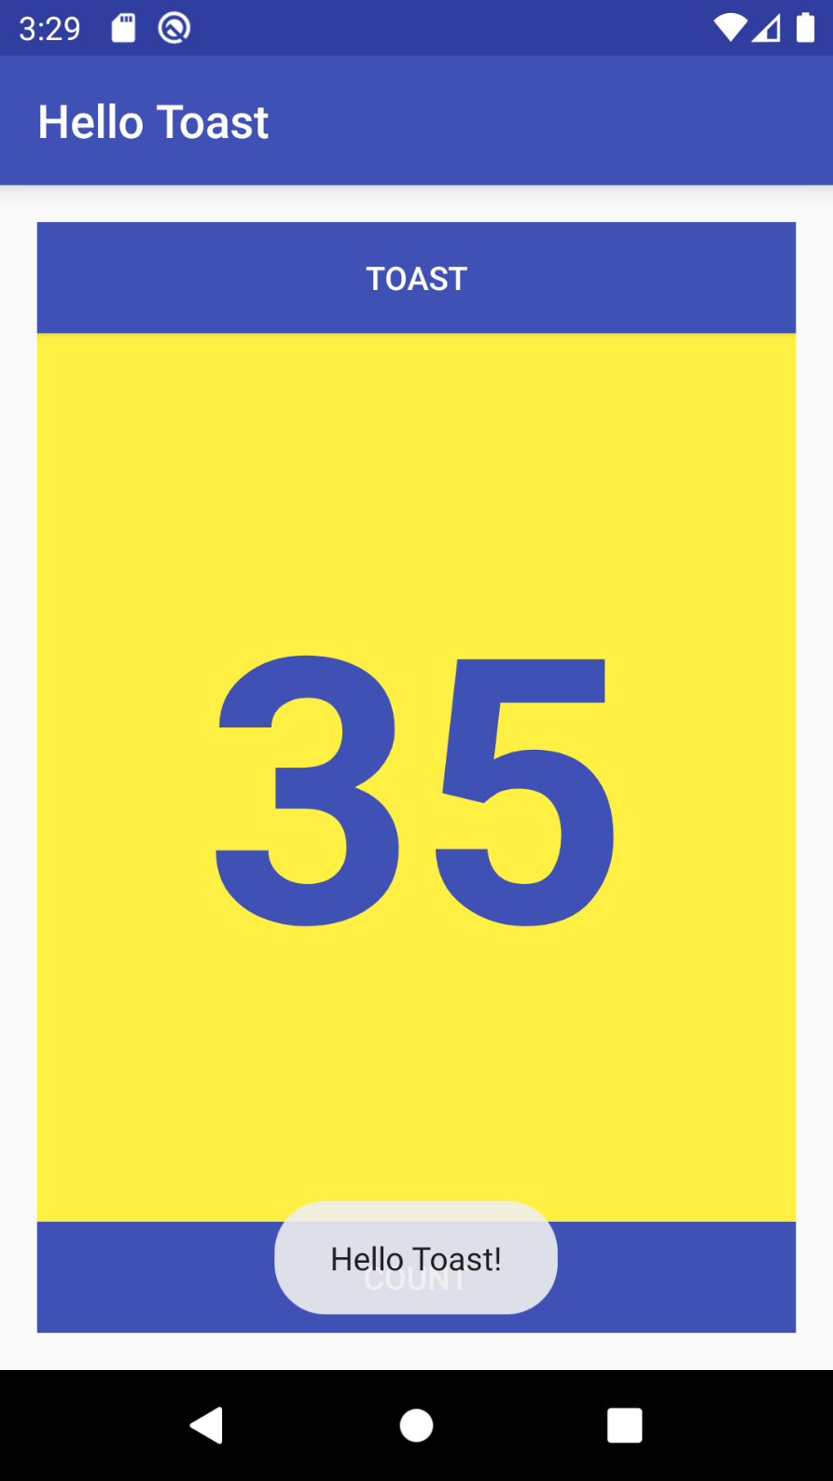

**Layout 🡺** activity_main.xml

*<?***xml version="1.0" encoding="utf-8"***?>*<**LinearLayout xmlns:android="http://schemas.android.com/apk/res/android"  
 xmlns:tools="http://schemas.android.com/tools"  
 android:layout_width="match_parent"  
 android:layout_height="match_parent"  
 android:orientation="vertical"  
 android:paddingBottom="@dimen/activity_vertical_margin"  
 android:paddingLeft="@dimen/activity_horizontal_margin"  
 android:paddingRight="@dimen/activity_horizontal_margin"  
 android:paddingTop="@dimen/activity_vertical_margin"  
 tools:context="com.example.android.hellotoast.MainActivity"**>  
  
 <**Button  
 android:id="@+id/button_toast"  
 android:layout_width="match_parent"  
 android:layout_height="wrap_content"  
 android:background="@color/colorPrimary"  
 android:onClick="showToast"  
 android:text="@string/button_label_toast"  
 android:textColor="@android:color/white"** />  
  
 <**TextView  
 android:id="@+id/show_count"  
 android:layout_width="match_parent"  
 android:layout_height="wrap_content"  
 android:background="@color/myBackgroundColor"  
 android:gravity="center"  
 android:text="@string/count_initial_value"  
 android:textColor="@color/colorPrimary"  
 android:textSize="@dimen/count_text_size"  
 android:textStyle="bold"  
 android:layout_weight="2"**/>  
  
 <**Button  
 android:id="@+id/button_count"  
 android:layout_width="match_parent"  
 android:layout_height="wrap_content"  
 android:background="@color/colorPrimary"  
 android:onClick="countUp"  
 android:text="@string/button_label_count"  
 android:textColor="@android:color/white"** />  
  
</**LinearLayout**>

**Java 🡺** MainActivity

**import** android.os.Bundle;  
**import** android.support.v7.app.AppCompatActivity;  
**import** android.view.View;  
**import** android.widget.TextView;  
**import** android.widget.Toast;  
  
**public class** MainActivity **extends** AppCompatActivity {  
  
 **private int mCount** = 0;  
 **private** TextView **mShowCount**;  
  
 @Override  
 **protected void** onCreate(Bundle savedInstanceState) {  
 **super**.onCreate(savedInstanceState);  
 setContentView(R.layout.***activity_main***);  
 **mShowCount** = (TextView) findViewById(R.id.***show_count***);  
 }  
   
 **public void** countUp(View view) {  
 **mCount**++;  
 **if** (**mShowCount** != **null**)  
 **mShowCount**.setText(Integer.*toString*(**mCount**));  
 }  
   
 **public void** showToast(View view) {  
 Toast toast = Toast.*makeText*(**this**, R.string.***toast_button_toast***, Toast.***LENGTH_LONG***);  
 toast.show();  
 }  
}

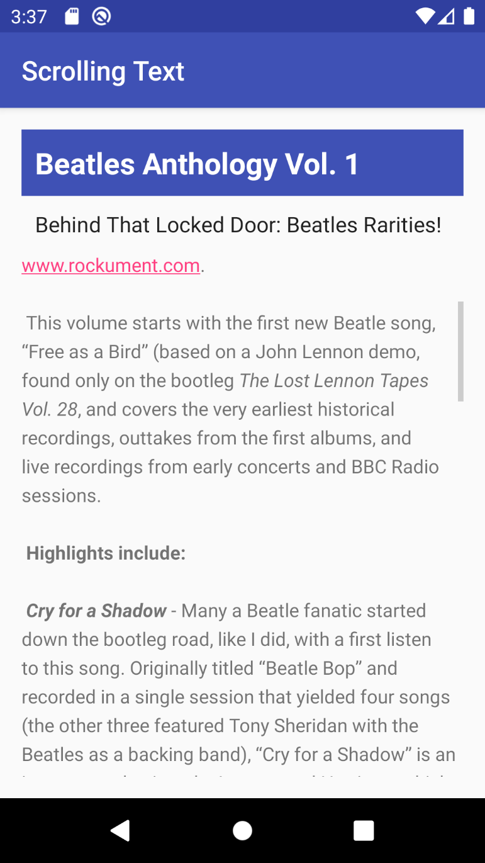**Scrolling text**

**Layout 🡺** activity_main.xml

*<?***xml version="1.0" encoding="utf-8"***?>*<**RelativeLayout xmlns:android="http://schemas.android.com/apk/res/android"  
 xmlns:tools="http://schemas.android.com/tools"  
 android:layout_width="match_parent"  
 android:layout_height="match_parent"  
 android:paddingBottom="@dimen/activity_vertical_margin"  
 android:paddingLeft="@dimen/activity_horizontal_margin"  
 android:paddingRight="@dimen/activity_horizontal_margin"  
 android:paddingTop="@dimen/activity_vertical_margin"  
 tools:context="com.example.android.scrollingtext.MainActivity"**>  
  
 <**TextView  
 android:layout_width="match_parent"  
 android:layout_height="wrap_content"  
 android:id="@+id/article_heading"  
 android:background="@color/colorPrimary"  
 android:textColor="@android:color/white"  
 android:padding="@dimen/padding_regular"  
 android:textAppearance="@android:style/TextAppearance.Large"  
 android:textStyle="bold"  
 android:text="@string/article_title"**/>  
  
 <**TextView  
 android:layout_width="match_parent"  
 android:layout_height="wrap_content"  
 android:id="@+id/article_subheading"  
 android:layout_below="@id/article_heading"  
 android:padding="@dimen/padding_regular"  
 android:textAppearance="@android:style/TextAppearance"  
 android:text="@string/article_subtitle"**/>  
  
 <**ScrollView  
 android:layout_width="wrap_content"  
 android:layout_height="wrap_content"  
 android:layout_below="@id/article_subheading"**>  
  
 <**TextView  
 android:layout_width="wrap_content"  
 android:layout_height="wrap_content"  
 android:id="@+id/article"  
 android:lineSpacingExtra="@dimen/line_spacing"  
 android:autoLink="web"  
 android:text="@string/article_text"**/>  
 </**ScrollView**>  
  
</**RelativeLayout**>